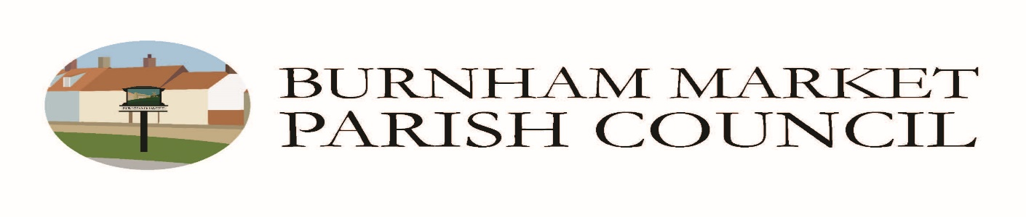

Application for Allotment Garden:
Livestock Fencing, Structures, Trees and Hedges

Please refer to your Allotment Tenancy Agreement and Rules & Regulations documents for information relating to Fencing, Structures and Trees prior to making your application.

All applications for allotment garden fencing, structures (including sheds, poly tunnels and housing for livestock), trees or hedges and livestock should be made using this form, including a plan showing the position of the fencing, structure, tree and drawn to scale. If necessary, please use a separate sheet and attach to the completed form.

Please sign and return the form/plan to the Parish Clerk.

Once approved you will receive a letter confirming permission from the Council.

In order to help avoid disputes, and permissions potentially being withdrawn, the council recommends discussing these matters with neighbouring allotment holders. Particular care should be taken to avoid obstructing pathways, adjacent plots and loss of light.

Name of Allotment Holder

Address of Allotment Holder

Plot Number

Description of Fencing (position, size, materials)

Description of Structure (type: Shed, Greenhouse, Poly tunnel or Livestock housing - position, size, materials)

Description of Tree or Hedge (variety, position, size when fully grown)

Description of Livestock (type, number of)

Council Use Only:

Date application received
Date considered by Council

Advised to Tenant

