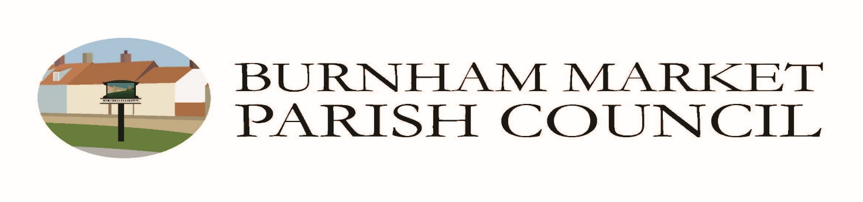
Additional Rules & Regulations for Allotment Garden Lettings / Conditions of Tenancy
(s. 28 Small Holdings and Allotments Act 1908)

Reviewed April 2022

To be used in conjunction with BMPC Tenancy Agreement for an Allotment Garden (11/2020)

- Livestock
Livestock, as permitted by s. 12 Allotments Act 1950 - domestic chickens (no cockerels) and rabbits - are permitted provided written permission from the Council is obtained. No other livestock is permitted.
In order to protect their welfare, the keeping of livestock is restricted to only permanent residents of Burnham Market.
Livestock should not be kept in such a manner as to be prejudicial to health and wellbeing or a nuisance.
The British Hen Welfare Trust guidelines can be found at www.bhwt.org.uk

2. Pest control
Responsibility for pest control if you notice sits with the Parish Council should be reported to the PC Clerk or Allotment Committee member.
The use of poisons or firearms by tenants for pest control is not permitted.

3. Structures (sheds, greenhouses, poly tunnels, livestock housing)
- All new structures require written permission before they are erected - an application should be made to the Council including size and position (see separate guidance and application form)
- Allotment buildings should be kept in good repair; smaller sheds should be secured to prevent wind damage to them and neighbouring allotments and persons
- No glass should be used for greenhouses or tunnels
- Allotment plot holders with buildings not kept in good repair will be given a written warning and 2 months’ notice to repair or remove; the Council reserves the right to remove or dispose of dangerous structures and charge the tenant accordingly

MAX. SIZE OF SHED - BO Shed 10 x 8, Greenhouse 6 x 12, Poly tunnel 9 x 15 per 10 rod allotment

4. Trees & Hedges
Written permission from the Council is necessary before any tree or hedge is planted using the Application Form.
Written permission is necessary before any tree is cut down, lopped or branches removed. Permission of the Borough Council for such works may be necessary in the first instance, followed by consideration of the Parish Council.

5. Boundaries and Pathways
No barbed wire to be used as a fence or part of a fence or any other part of the allotment.
Pathways should be maintained by allotment holders between plots.

6. Dogs
Dogs brought to the site by tenants should be kept on leads on the tenant’s own allotment; straying onto adjacent plots is not permitted and all fouling should be removed.
7. Bonfires
Small bonfires for allotment debris only are permitted on the tenant’s own plot and must be attended at all time. These should only be lit if of no nuisance to neighbouring allotments, properties or hedgerows.

8. Deposits
A deposit of £50 per standard plot (10 rod), £25 half plot, shall be paid by new tenants and existing tenants wishing to rent additional allotments to secure their plots. This deposit is refundable on termination of the tenancy following a satisfactory inspection of the allotment - i.e. left in good cultivated order with any rubbish or structures removed.

9. Disputes
Any disputes must be referred to the Council whose decision is final.

Original November 2020
Reviewed April 2022

