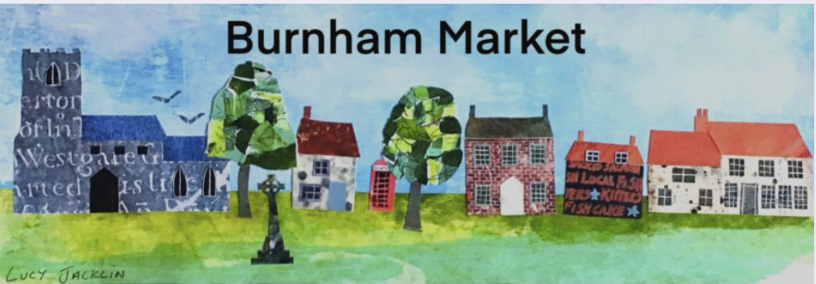

Neighbourhood Development Plan

Shape the future of our village
Regulation 14 Consultation
on the pre-submission draft Plan takes place

1st October to 25th November 2022

1

VIEW

Draft Plan and supporting documents available on Parish Council website:
www.burnhammarketpc.info/ neighbourhood-plan

Printed copies for reference are in the village telephone box and porch of St Mary’s Church.
2

DROP-IN SESSIONS
Sutton Lea Community Room Wednesday,
12th October 10am to noon

Village Hall Thursday, 13th October
10am to noon and 5pm to 7pm
3

COMMENT

Via online questionnaire at: www.smartsurvey.co.uk/s/BMarket/
Paper copies available on request from the Parish Clerk, Caroline Boyden at:

parishclerk@burnhammarketpc.uk or
Tel: 07437 529179

Burnham Market Parish Council
Our Village Our Plan Your Say

